

A Veteran owned and CCR Registered Small Business
5946 Millbury Court
Charlotte NC 28211
EMail: galden@pooldesignconsultants.com Telephone 704/362-3144
Web Site at www.pooldesignconsultants.com Fax 704/362-3145

Facility: Granite Falls Swim and Athletic Club
Rolesville NC

Reference: Jacky Wilson
919 786 4162

Pool portion of contract: $1.8 Million
Completion Date: June 2009

Aquatic facility narrative:

General attributes:

- Scope of design by Pool Design Consultants
  - Indoor pool
  - Outdoor Lazy River
  - Outdoor Combination Pool
  - Outdoor Wading Pool
  - Deck
  - Hydraulic design by PDC
- Scope of design by the architect
  - All other components

The multiple use aquatic facility was designed per the following design criteria:
- NC Department of Environment and Natural Resources T15A: 18A .2500 NC DENR, DEH Environmental Health Services March 1, 2004 SECTION .2500 - PUBLIC SWIMMING POOLS
- VGBA 2008

The multiple use aquatic facility was designed for the following activities:

      - Indoor Competition pool
      - Lap swimming
      - Large deck area to accommodate high volume use
      - Aerobics
      - Leisure activities
      - ADAAG access
      - Outdoor slide feature
      - Outdoor water features
      - Outdoor lazy river

The multiple use aquatic facility was designed for the operational attributes:

      - Automated sanitation systems
      - Institutional quality hydraulic systems
      - Automated water level control systems

Sincerely,

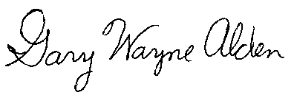

Gary Wayne Alden

